Southlands Electric Screen Shots

Create Tables and Add constraints & Indexes.

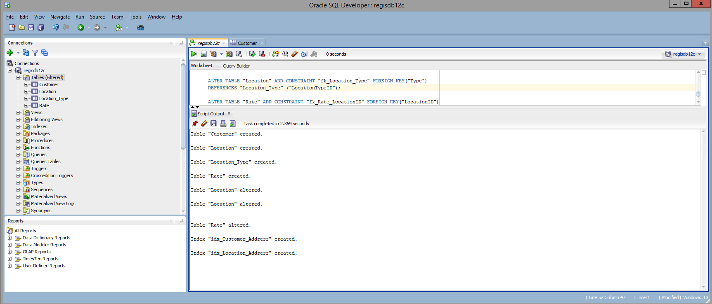

Inserting Fake Data into Database.

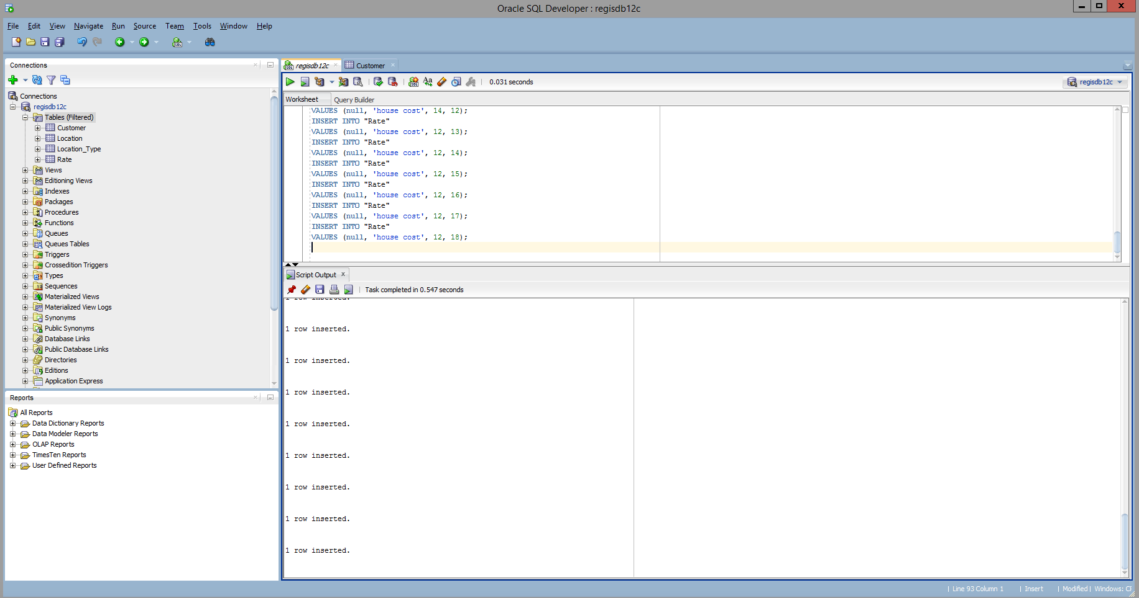

Showing all tables and their Rows.

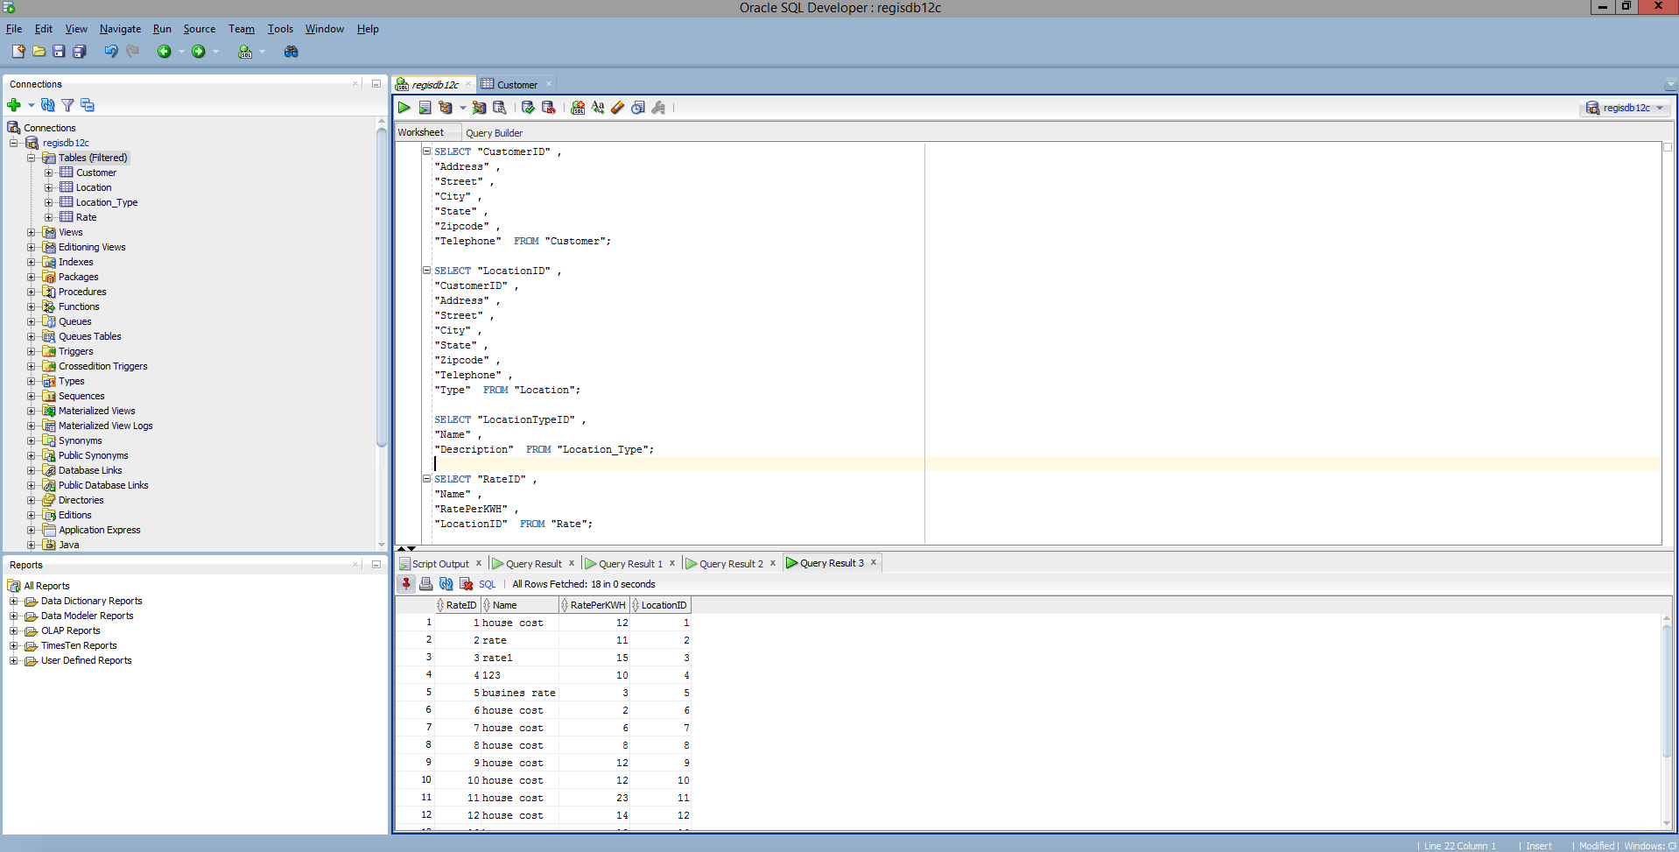

Lists the location type and the rates by time of day.

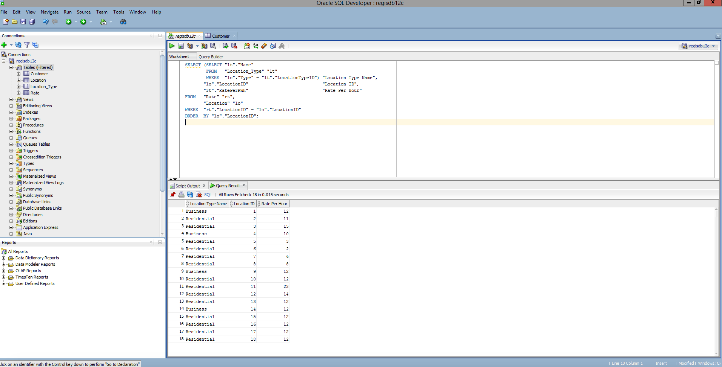

Lists each customer by name with location addresses.



